BJ Bloemker

A20372354

1. English Descriptions
   1. The language is limited to numbers 1, 2, 3, 4, 5, 6, 7, 8, 9, 19, 20, and dash (-)  
        
      The first digits must be either *19* or *20* directly followed by two single digit numbers. After the numbers there needs to be a space. The second part of this language has three different options. Each option begins with a space.  
        
       For the first case, you can then a *0* or nothing at all. After that another space, and then a single digit number, followed finally by a space.   
        
      The second case, you put a space and you can either put a *1* or a *2* immediately followed by a single digit number and concluding with a sace.  
        
      The third case, you must put a space and then a three. After that, any single digit number can be placed.  
        
      All of the following are valid examples:  
      1st example case: 1955- 0 5 OR 1955- 5  
      2nd example case: 2044- 15   
      3rd example case: 1998- 31
   2. The language is limited to numbers #17:, 1, 2, 3, 4, 5, 6, 7, 8, 9, a, b, c, d, e, f, g, h, +, and -  
        
      The second language must start with the exact characters *#17:* This is then followed by either any single digit number or any single character from the following list: [*a,b,c,d,e,f,g,h*]. Then, that is followed by a space and any combination of number and characters (from the same list above). Then, a space followed by the character *e* and another space. From there, you can put a + or a - or nothing followed by another space. That leaves you to write any number of digits, as long as you like.   
        
      All of the following are valid examples:   
        
      #17:1 aaaaaaaa e + 151232152315  
      #17:h aaaaaaaa e 151232152315  
      #17:3 ah7d565d e - 25651652531  
      #17:9 7 e - 256516523
2. Reg expressions
   1. ( (aa[^a]*)* | (bbb[^b]*)* )
   2. ( [^a]|a[^b]|ab[^c])*(a|ab)?
3. Reg expressions
   1. (^|[ ])([1-9]\d*|0) ← add /m for multiline use
   2. (^|[ ]|[-+])([1-9]\d*|0)(e[+-]?[0-9]+)?
   3. (([0-9])*)?(\.[0-9]+)*(e[-+]?[0-9]+)?
   4. 0x([0-9a-fA-F]+)
4. Reg expression to NFA  
   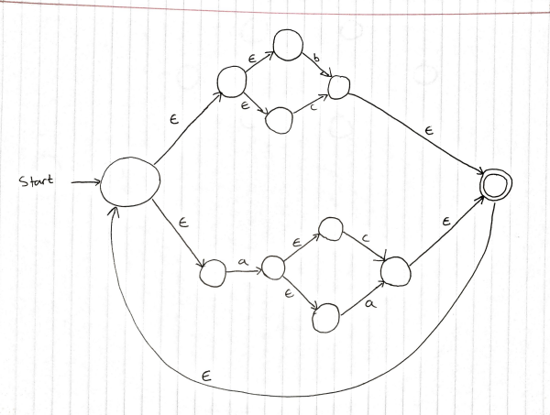
5. NFA to DFA Conversion

|  |  |  |
| --- | --- | --- |
| State | Epsilon-Closure | Result |
| A | {0} | {0,1,2,3} |
| B | {4,5} | {4,5} |
| C | {6} | {6} |
| D | - | - |
| E | {7} | {0,1,2,3,7,9,10} |
| F | {8} | {0,1,2,3,7,9,10} |

|  |  |  |  |
| --- | --- | --- | --- |
| DFA States | a | b | c |
| A | B | C | D |
| B | D | E* | F* |
| C | D | F* | D |
| D | D | D | D |
| E* | B | D | D |
| F* | B | D | D |

